1. Open Bus Hound

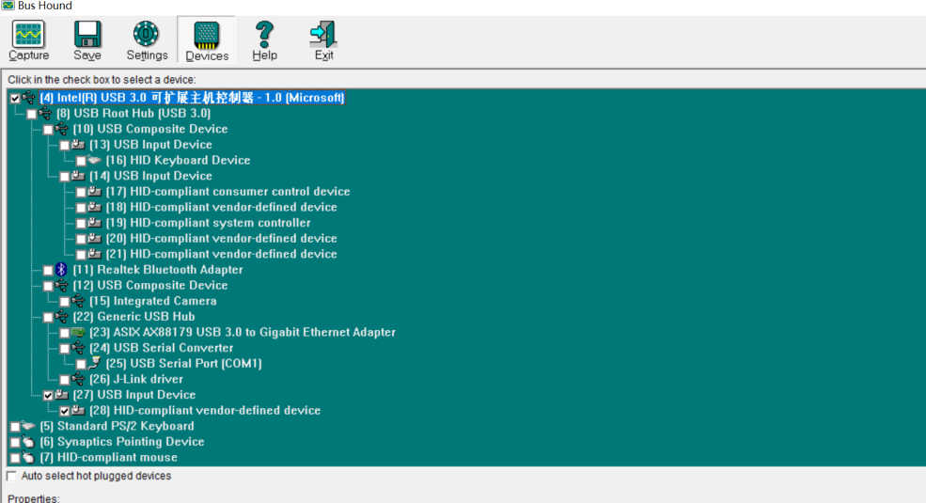

1. Double click “USB Input Device ----27”, the following interface will show up.

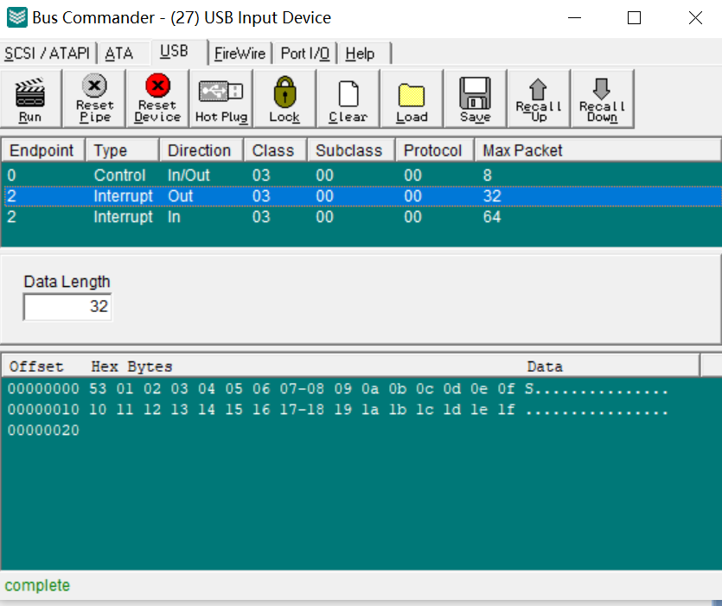

1. Click “Interrupt out, Data Length”----Input “32”

Then you could input 32 bytes data, after input them, press “Run”.

This step could be ignored at present.

1. Click “Capture” to capture the data

